*Heaven’s Light is Our Guide*

**Rajshahi University of Engineering & Technology**



Department of Electrical & Computer Engineering

**System Analysis**

**of**

**Technical Training Center(TTC), Rajshahi**

**Course No:** ECE 3118

**Course Title:** Software Engineering & Information System Design Sessional

**Submitted By:**

**Submitted To :**

Rakibul Hassan

Assistant Professor

Dept. of ECE,RUET

1. Name: Safal Kumar Biswas

Roll: 1810056

1. Name: Israt Zahan

Roll:1810057

1. Name: Ahmad Nafi

Roll:1810058

4.Name:M.Morsedur Rahman

Roll:1810059

5. Name: Mahdi Hasan

Roll:1810060

**CONTENTS**

|  |  |  |
| --- | --- | --- |
| **CHAPTER** | **TITLE** | **PAGE NO** |
| **Chapter 1** | **Recognition of Need** | **01-05** |
|  | 1.1 Introduction | 01 |
|  | 1.2 Objectives of Technical Training Center, Rajshahi | 02 |
|  | 1.3 Vision and Mission of the organization | 02 |
|  | 1.4 Problem Identifications | 02 |
|  | 1.4.1. No online admission system | 03 |
|  | 1.4.2. Absence of student’s profile | 03 |
|  | 1.4.3. Lack of online resource | 03 |
|  | 1.4.4. Online/mobile banking | 03 |
|  | 1.4.5. Shortage of training of trainer’s | 03 |
|  | 1.4.6. Not having updating curricula | 03 |
|  | 1.4.7. Insufficient performance monitoring and evaluation | 04 |
|  | 1.4.8. Bad condition of training car | 04 |
|  | 1.4.9. Shortage of recreation | 04 |
|  | 1.4.10. Shortage of security guard: | 04 |
|  | 1.4.11 Insufficient advertisement | 04 |
|  | 1.4.12 Not having cafeteria | 05 |
|  | 1.4.13 Lack of Man Power | 05 |
|  | 1.4.14 Inadequate Staff Quarter | 05 |
|  | 1.5 Conclusion | 05 |
| **Chapter 2** | **Initial feasibility studies** | **06-10** |
|  | 2.1 Introduction | 06 |
|  | 2.2 Initial feasibility study | 06 |
|  | 2.2.1 No online admission system | 06 |
|  | 2.2.2 Absence of student’s profile | 06 |
|  | 2.2.3 Lack of online resource | 07 |
|  | 2.2.4 Online/mobile banking | 07 |
|  | 2.2.5 Shortage of training of trainer’s | 07 |
|  | 2.2.6 Not having updating curricula | 08 |
|  | 2.2.7 Insufficient performance monitoring and evaluation | 08 |
|  | 2.2.8 Bad condition of training car | 08 |
|  | 2.2.9 Shortage of recreation | 08 |
|  | 2.2.10 Shortage of security guard | 09 |
|  | 2.2.11 Insufficient advertisement | 09 |
|  | 2.2.12 Not having cafeteria | 09 |
|  | 2.2.13 Lack of Man Power | 09 |
|  | 2.2.14 Inadequate Staff Quarter | 10 |
|  | 2.3 Conclusion | 10 |
| **Chapter 3** | **Information Gathering** | **11-21** |
|  | 3.1 Introduction | 11 |
|  | 3.2 Information gathering using different tools | 12 |
|  | 3.2.1 Forms, documents and statistical chart of technical training center,Rajshahi. | 12 |
|  | 3.2.1.1 Name of all the department | 12 |
|  | 3.2.1.2. Advertisement for admission | 13 |
|  | 3.2.1.3 Training schedule | 14 |
|  | 3.2.1.4 citizen charter | 15 |
|  | 3.2.2 Observation on working process of technical training center | 16 |
|  | 3.2.3 Face to face question answer session | 17-18 |
|  | 3.2.4 Information collected by opinion poll | **18-19** |
|  | 3.3 Overview of the candidate examination control system | 20 |
|  | 3.3.1 A brief description of examination control system | 21 |
|  | 3.3.2 Conclusion | 21 |
| **Chapter 4** | **Feasibility Study** | **22-31** |
|  | 4.1 Introduction | 22 |
|  | 4.2 Feasibility analysis | 22 |
|  | 4.2.1 No online admission system | 22 |
|  | 4.2.2 Absence of student’s profile | 23 |
|  | 4.2.3 Lack of online resource | 23 |
|  | 4.2.4 Online/mobile banking | 24 |
|  | 4.2.5 Shortage of training of trainer’s | 24 |
|  | 4.2.6 Not having updating curricula | 25 |
|  | 4.2.7 Insufficient performance monitoring and evaluation | 25 |
|  | 4.2.8 Bad condition of training car | 26 |
|  | 4.2.9 Shortage of recreation | 26 |
|  | 4.2.10 Shortage of security guard | 27 |
|  | 4.2.11 Insufficient advertisement | 27 |
|  | 4.2.12 Not having cafeteria | 28 |
|  | 4.2.13 Lack of Man Power | 29 |
|  | 4.2.14 Inadequate Staff Quarter | 30 |
|  | 4.3 Conclusion | 31 |
| **Chapter 5** | **Input/Output Form** | **32-37** |
|  | 5.1 Introduction | 32 |
|  | 5.2 Form Design for Technical Training Center (TTC) | 32 |
|  | 5.2.1 Student Information related form | 33-34 |
|  | 5.2.2 Instructor Information related form | 35-36 |
|  | 5.3 Conclusion | 37 |
| **Chapter 6** | **Database Design** | **38-41** |
|  | 6.1 Introduction | 38 |
|  | 6.2 Database for Organization management system | 38 |
|  | 6.2.1 Entity Relationship Diagram | 39 |
|  | 6.2.2 Structure of tables | 40-41 |
|  | 6.3 Conclusion | 41 |
| **Chapter 7** | **Summary of System Analysis and Design on Technical**  **Training Center, Rajshahi** | **42-44** |

**Chapter – 1**

**Recognition of Need**

**1.1 Introduction**

* **Preface:**

Rajshahi Technical Training Center is one of the old and large technical training centers in the history of skills development in Bangladesh. This technical training center is established to train the manpower for local and global market. Training is delivered in different employable trade as per the demand of local   and overseas job market. In keeping with changing Technology Rajshahi Technical Training Center is capable to start any courses on emerging technology. Course curriculum of RTTC is always updated in line with demand. Innovation in all sectors is always considered in teaching-learning. Technical Training Centre, Rajshahi always thinks for skills and quality of graduates. Since knowledge and skills are becoming the future currency, so Rajshahi TTC always try to do the best and the new things.

* **Brief History:**

Technical Training center, Rajshahi of north Bengal is one of the famous TTC among the old 11 TTCs. It works in the direction of Bureau or Manpower, Employment & Training under the Ministry of Expatriates welfare & overseas Employment of Government of the people’s Republic of Bangladesh.

Rajshahi Technical Training Center was established in 1967 to provide unemployment people by skill training program. This institution initially stared with the financially & technical assistance of SEATO. Now S.S.C (voc) & Short courses are successfully going on. The objective of short Courses is to produce skill human resources for employment for earning foreign currency.

Very recent, Computer Graphics Design lab and Auto CAD Lab was remodeled under the financially & technical assistance of KOICA (Korea International Cooperation Agency).

The center is now going to offering CBT&A programs under new National Skill Development policy with a view to impart knowledge and skills, to the trainees using modern technology in keeping with the changes in the local and global market.

**1.2 Objectives of Technical Training Center, Rajshahi**

* To ensure that all trainees have the technical skills that they needed.
* To maintain the services & products.
* To motivate trainees to achieve world class skills.
* To decrease the risk of training place that the trainees can feel safe.
* To upgrade professional and managerial skills.
* To provide courses in digital format like online system of teaching.
* To encourage the trainees to achieve their goal
* To provide opportunity of skill development and technical education to all sections of the society without any gender bias.
* To ensure the quality of environment.
* To provide positive attitude towards science and technical part.

**1.3 Vision and Mission of the organization**

* Facilitating world-class Department of Technical Education, Training and Skill Development through emphasis on developing high quality institutions, academic excellence and innovative research and development programmers.
* To provide leadership in assuring quality and in stimulating innovation in technical sector.
* Anticipate and prepare for the changing environment and the future needs in pursuits of technical advancements.
* The ability to adapt and upgrade individual skills in a rapidly changing world
* To assist the people in making educational and career decisions.
* To make informed consumer decisions and apply practical life skills.​
* To impart Technical Education & Training, to provide substantial number of technicians in different disciplines for the emerging industrial fields of the country.
* Promoting industry-institute interaction for developing new products, services, and patents.
* To Transfer technical knowledge at the grassroot level.

**1.4 Problem Identifications:**

**1.4.1. No online admission system**: Students cannot enroll or admit themselves using website. There is option for offline admission but this is not efficient and cost effective. Offline admission system is very complex system and it it very hard to maintain proper time /schedule in this system. There is need of enough manpower in this system which is not cost effective. If they make the admission system in online students from distant area can easily admit themselves.

**1.4.2. Absence of student’s** **profile:** They don’t provide individual profile for students, employee and teachers. If they could give or maintained individual profile, student’s could view their result, can get update about their course, routine and notice. This is a very systematic way to maintain student’s profile. Student’s can see their result and grade individually. This system will make institution’s privacy more strong. And also teacher can monitor improvement of the student.

‘Sign-up’ option should be added on the website, so that when anyone do sign-up by giving necessary information a profile will generate.

**1.4.3.** **Lack of online resource:** There is not any syllabus, details and course curriculum for specific course in the website. If students can see the course curriculum on the website they will get some advanced idea. And, there is lack of list of necessary books, pdf, article and video tutorial about a particular course. Student’s will not get proper idea about their courses before admitting themselves. There are no necessary pdf files or books. So, during study they will not get enough materials and resources.

**1.4.4. Online/mobile banking:** At least course fee and admission fee should be received using mobile banking such as bkash, rocket etc. Now a days, mobile banking is available and vastly used. If the authority receive payment by mobile banking ,student’s will get benefit. This system will help the authority to handle the situation in a more systematic way and efficiently. It will consume less time and less number of employee. The environment of the institution will be more stable, training and teaching will not be hampered.

**1.4.5. Shortage of training of trainer’s:** In this organization there is a critical shortage of training of trainers which can become threatening for the future training program. The trainers teach the trainee according to their previous learning. The trainers of various sectors are well experienced -no doubt but to keep pace with this competitive world by their skills, they should be trained. Without proper training they can’t teach the trainee properly what the trainee actually needs to know to prepare themselves for suitable jobs.

**1.4.6. Not having updating curricula:** Technical Training Center (TTC), Rajshahi has 16 different fields of training. All the fields have particular curricula in order to enhance student learning and facilitate instruction. But these curricula are not totally up to date. Curriculum is the central guide for teaching and learning. But by this not updated curriculum the trainees are taught subjects or concepts that are no longer relevant. Thus, the training may not be so much effective for the trainee.

**1.4.7. Insufficient performance monitoring and evaluation:** The trainee of TTC can take short term courses which duration can be 6 months or can participate in long term courses which duration is more than 1 years. There is a vocational board which conducts the evaluation of the trainee. But in this organization, internally there has no option to evaluate the performance of the trainee. By this internal evaluation the trainee can know their lacking and correct them before the final evaluation of the vocational board. Even the organization does not arrange “class test” type examination to monitor whether the trainee actually can perform the tasks.

**1.4.8. Bad condition of training car:** The cars, that have used in driving trade, are have in very bad condition. The are certainly not in shape of driving & it is quite risky to a car in that condition. They also use the TTC inner road as driving way. But both the authority & the instructor are willing to use them in for training purpose. Again, they have better quality cars. But they don’t use it for driving purpose. Which is nothing but negligence of the authority.

**1.4.9. Shortage of recreation:** There in a small field in TTC area. But, that one not able to cover up the annual program for a single trade. Again, the annual program is only for those students those are enrolled in the long-term courses. But there are no such things for the students on short-term courses. Further, they don’t have any scope of sightseeing tour. Anyway, recreation do impact on education. Shortage of recreation can be a great problem in long run.

**1.4.10. Shortage of security guard:** The TTC area is quite big with 16 trade & intermediate level college education system. Again, they have a separate area for women training purpose. But, in this whole area, there is not a single guard checkpoint. Even in the main gate of TTC there is a guard. But he also not concern about the outsider who came into this area. Anyone can roam into the area, without ant permission. It may normal for an educational institute, but for women’s separate area of training, it is uncomfortable to them. Again, some guard’s checkpoint can observe the area in better way.

**1.4.11 Insufficient advertisement:** Only the proper advertisement can give the appropriate information about the organization and can depicts the significance of technical knowledge in this modern era. This organization manages student/trainee by submitting leaflet, giving post on various social media and through the newspaper. Thus a few people can know about the importance of technical knowledge and skills. For this lack of organizational advertisement, it creates the shortage of the number of the trainee. There was so many modern equipment of high cost which were imported from Korea but most of them are being unused for the lack of trainee.

**1.4.12 Not having cafeteria:** In this organization, there is no canteen or cafeteria. During the break time of the courses, there is on chance of the trainee to get foods inside the campus. Even there is no tea stalls or hotel nearby the organization. So the trainee have to go a long distance when they need to take any food. After taking the snacks from the long distance, when they come back to their classes, they often miss some portion of the course lecture. This reason is disrupting their training.

**1.4.13 Lack of Man Power:** In this time there are 1500 students/trainee who have enrolled in various courses. For their training, there are only 55 instructors. The number of instructor is very smaller compare to the number of trainee. We have also learned that there is only one foreign instructor from Korea who acts as a monitor of the training courses through online. It is very difficult task for a monitor to supervise all the arena of the training courses.

**1.4.14 Inadequate Staff Quarter:** There are only 5 two storied building in the compound for the instructors where there works 55 instructors in current time. The facilities of this organizations can support only 10 families of the instructor. Most of the instructors remain deprive of the accommodation facilities. So they have to rent houses outside of the organization at a high cost. Moreover, many instructors have to come from a far distance. In this case, it adds transportation cost with the living cost which greatly hampers the financial condition of the instructors.

**1.5 Conclusion:** Technical Training Center (TTC), Rajshahi has its great mission and vision and this organization is trying to fulfil its organizational goal. While doing initial survey on the existing system of TTC, we found some problems. But we don’t know whether these problems can be solved or not. This can be understood after initial feasibility. Thus we will try to find out the solution of these problems and go through some sequential stages to build up a candidate system.

**Chapter-2**

**Initial feasibility studies**

**2.1 Introduction**

An initial investigation culminates in a proposal that determines whether an alternative system is feasible. A proposal summarizing the thinking of the analysis is presented to the user for review. When approved, the proposal initiates a feasibility study that describes and evaluates candidate system performance requirements.

Depending of the results of the initial investigation, the survey is expanded to a more detailed feasibility study. A feasibility study is a test of system proposal according to its workability, impact on the organization, ability to meet user needs, and effective use of resources. It focuses on three major questions:

* What are the user’s demonstrable needs and how does a candidate system meet them?
* What resources are available for given candidate systems? Is the problem worth solving?
* What are likely impact of the candidate system on the organization? How well does it fit within the organization’s master MIS plan?

Each of the question must answer carefully. They revolve around investigation and evaluation of the problem, identification and description of candidate systems, specification of the performance and the cost of each system and final selection of the best system.

**2.2 Initial feasibility study**

**2.2.1 No online admission system**

It was observed the students cannot enroll or admit themselves using website. Offline admission system is very complex system and it very hard to maintain proper time /schedule in this system. There is need of enough manpower in this system which is not cost effective.

The process can be performed online. If they make the admission system in online students from distant area can easily admit themselves. This process is not worthy cause to make the admission system online, there will be need of buying own server, more technical employee will be needed which are not cost effective.

**2.2.2 Absence of student’s** **profile**

This technical Centre don’t provide individual profile for students, employee and teachers.

This problem is worth solving cause by making individual profile for the students it can be ensured that If student’s can view their result, can get update about their course, routine and notice. Students can see their result and grade individually. And also teacher can monitor improvement of the student. ‘Sign-up’ option should be added on the website, so that when anyone do sign-up by giving necessary information a profile will generate. This process don’t need continuous man power and technical specialist. There will be no need of buying server own self. To create this process resources are also available. And it’s a cost effective way to maintain students’ progress.

**2.2.3**  **Lack of online resource**

There is not any syllabus, details and course curriculum for specific course in the website. If students can see the course curriculum on the website they will get some advanced idea. And, there is lack of list of necessary books, pdf, article and video tutorial about a particular course. Students will not get proper idea about their courses before admitting themselves. There are no necessary pdf files or books. So, during study they will not get enough materials and resources.

To publish these information, the technical center need having own server and technical people which is not economically effective. That’s why this process is not worth solving.

**2.2.4**  **Online/mobile banking**

The course fee and admission fee should be received using mobile banking such as bkash, rocket etc. Now a days, mobile banking is available and vastly used. If the authority receive payment by mobile banking, students will get benefit. This system will help the authority to handle the situation in a more systematic way and efficiently. It will consume less time and less number of employee. The environment of the institution will be more stable, training and teaching will not be hampered.

This problem is not worth solving cause the technical center need to buy own server and need more technical people. Moreover for maintain online banking the technical center will be dependent on third party online banking system like bkash, rocket etc. which is not suitable for privacy of the technical center.

**2.2.5**  **Shortage of training of trainer’s**

This organization have a critical shortage of training of trainers which can become threatening for the future training program. The trainers of various sectors are well experienced -no doubt but to keep pace with this competitive world by their skills, they should be trained. Without proper training they can’t teach the trainee properly what the trainee actually needs to know to prepare themselves for suitable jobs.

This problem is worth solving because nowadays there have thousands of resource for learning and getting required informationfrom online. From these resources trainers can trained themselves with the updated system of specific field.

**2.2.6 Not having updating curricula**

Technical Training Center (TTC), Rajshahi has 16 different fields of training. All the fields have particular curricula in order to enhance student learning and facilitate instruction. But these curricula are not totally up to date.

This problem is not worth solving because the ongoing curricula is good enough to learn and gain knowledge and skill about the individual field of training. That’s why there have no need of new or updated curricula.

**2.2.7 Insufficient performance monitoring and evaluation**

The trainee of TTC can take short term courses which duration can be 6 months or can participate in long term courses which duration is more than 1 years. In this organization, internally there has no option to evaluate the performance of the trainee. Even the organization does not arrange “class test” type examination to monitor whether the trainee actually can perform the tasks.

This problem is worth solving because it is very easy and cost effective to monitoring performance and evaluation by taking day by day class test or weekly test. This will help the students to know about his own situation and where he/she need to progress.

**2.2.8 Bad condition of training car**

The cars, those have used in driving trade, are have in very bad condition. They are certainly not in shape of driving & it is quite risky to a car in that condition.

This problem is not worth solving because they use the TTC inner road as driving way. That’s why there have no risk of vast accident. Again, they have better quality cars so they can change the training car whenever they want.

**2.2.9 Shortage of recreation**

In the TTC there have no event or any programe for recreation of the students. Again, the annual program is only for those students those are enrolled in the long-term courses. But there are no such things for the students on short-term courses. Further, they don’t have any scope of sightseeing tour.

This problem is not worth solving because there have a small field in TTC area which is not able to cover up the annual program for a single trade. The students who enrolled in short-term courses have not enough time for recreation because it’s time duration is only 6 month. In this short period of time there have not much impact of recreation in training process rather than it can be a west of time

**2.2.10 Shortage of security guard**

The TTC area is quite big with 16 trade & intermediate level college education system. Again, they have a separate area for women training purpose. But, in this whole area, there is not a single guard checkpoint. Even in the main gate of TTC there is a guard. But he also not concern about the outsider who came into this area.

This is a large problem of TTC and it is worth solving. Shortage of guard causes lack of privacy and security in TTC area. If there have guard in different area it will prevent any kind crime and give the surety of safety. It will prevent unnecessary gathering of people.

**2.2.11 Insufficient advertisement**

This organization manages student/trainee by submitting leaflet, giving post on various social media and through the newspaper. Thus a few people can know about the importance of technical knowledge and skills. For this lack of organizational advertisement, it creates the shortage of the number of the trainee. There was so many modern equipment of high cost which were imported from Korea but most of them are being unused for the lack of trainee.

This problem is worth solving. Proper advertisement the organization will spread there facility, there vision and mission. Even the people who want to be technically updated will get information about their service and can enrolled themselves in the organization.

**2.2.12 Not having cafeteria**

In this organization, there is no canteen or cafeteria. During the break time of the courses, there is no chance of the trainee to get foods inside the campus. Even there is no tea stalls or hotel nearby the organization. So the trainee have to go a long distance when they need to take any food.

This is a huge problem and worth solving. The organization can establish a cafeteria of their own inside the campus which will help the students to get food easily. As there have no hotel nearby the organization, if there have a café students won’t need to go far away for food. Even from the café the organization can earn some extra money.

**2.2.13 Lack of Man Power**

In this time there are 1500 students/trainee who have enrolled in various courses. For their training, there are only 55 instructors. The number of instructor is very smaller compare to the number of trainee. We have also learned that there is only one foreign instructor from Korea who acts as a monitor of the training courses through online.

This is problem is worth solving. Lack of trainer will cause insufficient knowledge of the student in their individual training field. The organization need to appoint more instructor in different field so that the learning process become more effective. It will encourage people to enroll themselves in different field of training.

**2.2.14 Inadequate Staff Quarter**

There are only 5 two storied building in the compound for the instructors where there works 55 instructors in current time. The facilities of this organizations can support only 10 families of the instructor. Most of the instructors remain deprive of the accommodation facilities. So they have to rent houses outside of the organization at a high cost. Moreover, many instructors have to come from a far distance.

This problem is worth. By increasing staff quarter the organization can provide more facility for the instructor. More staff quarter will encourage the people to appoint themselves as an instructor. It’s safe and convenient for instructor to do their job effectively. It will reduce instructor economical losses. In future when the organization turn on more training field, more staff will be needed. That’s why sufficient staff quarter is much needed.

**2.3 Conclusion**

In this chapter we have done the initial feasibility study by which we can understand whether we can proceed with the problems or not. This is a crucial decision point in the life cycle. Many project die here, whereas the more promising ones continue through implementation. Changes in the proposal are made in writing, depending on the complexity, size, and cost of the project. It is simply common sense to verify changes before committing the project to design. We have to analyze more deeply to understand the situation and then finally we can assure that the identified problems can be solved.

**Chapter-3**

**Information Gathering**

**3.1 Introduction**

Information gathering is an art and a science.It requires technique ,sensitivity and knowledge in what and how to gather information. Additionally, the methodology and tools for information gathering require training and experience that the analyst is expected to have.So ,we can say it is a very sensitive part in system analysis because feasibility study and later parts depend on it.

To gather information from the organization different kinds of tools are used. The analyst must decide on the information gathering tool and how it must be used. Although there are no standard rules for specifying their use, an important rule is that information must be acquired accurately,methodically, under the right conditions and with minimum interruption to user personnel. So, it is necessary to be familiar with various information gathering tools. Each tool has a special function, depending on the information needed.

As we are going to make an analysis on the prevailing system of Technical training center,rajshahi. So we have gathered the required information from different sections of technical training center using four tools.

**3.2 Information gathering using different tools**

In this section we have presented the information we have collected from the respective

organization.

**3.2.1 Forms, documents and statistical chart of technical training center,Rajshahi**

**3.2.1.1 Name of all the department**

Here is the list of all the department and course.This institution have almost all the necessary and useful courses .

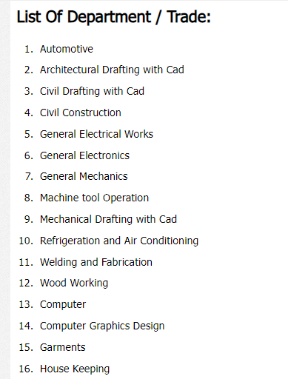

**3.2.1.2.Advertisement for admission:**This is a notice which is published before the admission season.Here we can see a name of a course,minimum educational qualification as a requirement, time range of the course.And we can also know the fee requirement for this particular course.

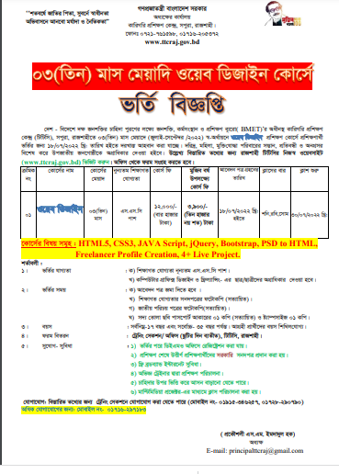

**3.2.1.3 Training schedule**

In this schedule there is list of the subcourses which are part of a course.Admission date for a specific course.The “course run” means the months on which training of these course will be given.This duration is generally 3-5 months or even years depending on the course.We can also be able to know the seat capacity for a specific course.

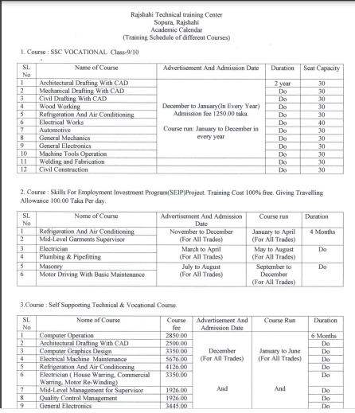

**3.2.1.4 citizen charter**

This is the list of the requirement,the information about how they will get the circular,the process of selection/admission,approximate time of admission for a specific course.They give circular by by giving advertisement in newspaper,supplying liflet,by giving notice to website.Applicant can get required form from the training section/office and website.After receiving application they take competitive admission test and select student.There is a specific time and a specific employee is assigned for all the courses.

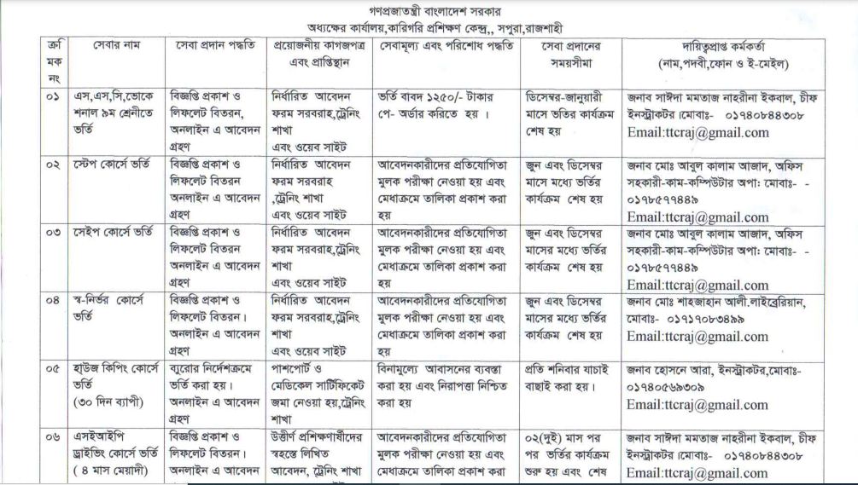

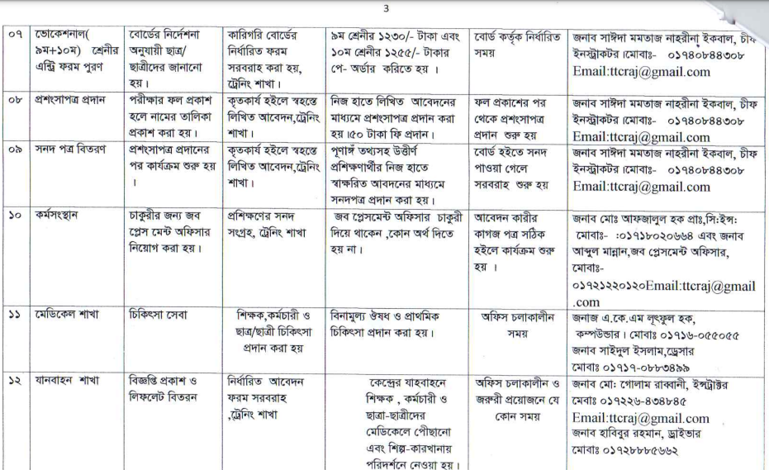

**3.2.2 Observation on working process of technical training center** :

Actually, this is known as onsite observation. Onsite observation is a very effective tool to gather information. The major objective of on-site observation is to get as close as possible to the real system. Keeping in mind the following questions, helps to gather important information observing the system.

• What kind of system we are observing.

• The people running the system and who are important people of the system.

• The history of the system and the evolution of the system to current stage.

• How the system responses to internal and external crisis. Four alternative observation methods are used usually.

• Observation can be natural or contrived. A natural observation occurs in employee’s place and contrived observation is set up by the observer in a place like laboratory.

• It can be obtrusive or unobtrusive. In an obtrusive observation the respondent knows he/she is being observed but in an unobtrusive observation the respondent doesn’t know.

• It can be direct or indirect. A direct observation takes place when the observer actually observes the subject. But in case of indirect observation mechanical devices are used to capture information.

• It can be structured or unstructured. In structured observation the observer looks for and records specific action. But in case of unstructured method, the observer is in a situation to observe whatever might be pertinent at the time.

We have observed the working process of technical training center,Rajshahi several times. Our observations were natural, direct, obtrusive and unstructured. Our observations are given below-

1.During our observation we saw that trainers are busy in the classroom.Specific skilled instructor is assigned in every section.Instructors are skilled and enough trained.Every instructor have to go through a training phase.In the general electrical works section trainees learn about the basic of electrical,they learn uses of various electrical tools in the lab and worked with those tools practically in the lab.In the final examination the give practical and written test.They also give viva .Officer comes from board in the exam time.

2.Technical resources are available in the training center.But there is not enough instructor for proper training.Instructors don’t know the use of multimedia projector.They give theoretical knowledge by writing on the white board.So it becomes quite hard for the students to understand and realize about a topic.They can see practical video and can get updated knowledge by the use of multimedia projector.

3.Number of students in the cources is not balanced.Some cources have students of full capacity but some cources have a few number of students.Main reason of this problem is lack of advertisement.They give circular using newspaper.But in this time most of the people don’t raed newspaper rather most of them are on social media.So if they give advertisement on social media it will be more efficient and effective.

4. During our observation the employees were very helpful and they were giving us information willingly when we told about the reason of observation.Instructors were busy in the classroom.Principle sir was very helpful and gave descriptive answer about all the asked question.

**3.2.3 Face to face question answer session**

We took interview of principle sir and instructor on this session. The interview is the oldest and most often used device for gathering information in systems work. It has qualities that behavioral and on-site observations do not possesses. It can be used for two main purposes: 1) It serves as an exploratory device to identify relations or verify information, and 2) It is used to capture information.

**To the principle**

Princple was very busy so we asked him a few question.

Interviewer: Is your organization capable to cope with marketing demand?

Interviewee:We give training to unemployed young people to make a skilled manpower.Yes we are capable of producing skilled manpower for marketing demand.We have proper facilities and skilled instructor.

Interviewer: Is your educational system digitalized?

Interviewee:We have updated and there is latest tools and machines in our lab.And we are trying to implement multimedia projector on the classroom.As our instructor are not trained in multimedia based education system we can not implement this now.

Interviewer: Do you have enough manpower?

Interviewee:Yes we have.There are currently 55 instructor and 33 staff in this training center.

Interviewer: .what is the procedure of admission system for the students?

Interviewee:We publish circular in the newspaper and supply liflet.Then applicant take the admission form by using website and office.Then we take competitive exam for selecting student.

Interviewer: Are the equipments enough for training?or any shortage?

Interviewee:Yes,we have enough equipments.

Interviewer: Is there any scholarship for the trainee?

Interviewee:We are not currently giving any scholarship.

Interviewer: How are the trainee evaluated and certified?

Interviewee:Written,viva and practical exams are taken on final examination.Officers from technical board comes on visit during the examination.

Interviewer: have you kept any recreation process for the trainee?

Interviewee:No ,there is not any co-crricular activities currently.

**Question To Instructor**

Interviewer: what is the ratio of male & female among running students?

Interviewee:There is not any specific ratio for male and female students.There is not any quota for male or female.

Interviewer: Are students regular?

Interviewee:Most of them are regular.

Interviewer: What is the duration of courses?

Interviewee:Generally 3 to 5 months.

Interviewer: Please explain the whole training system from student admission to certification?

Interviewee:We give proper training to all the students .This training period takes 3-5 months.They get proper practical knowledge.Then after that a final exam held under the technical board.In that exam written exam based on theory is taken by the board.Students also give practical exam and viva on that same day.

**3.2.4 Information collected by opinion poll**: This is also known as questionnaire. Questionnaire is an effective alternative of interview. If answer of the same questions is required from many people questionnaire is better than interview. It has several advantages over interview. In many cases it is economical and it requires less skills to get information. Also, many respondents feel better to answer the question in questionnaires rather than interview. We have also collected some information from the education board by using this technique. The form of the questionnaires is given below.

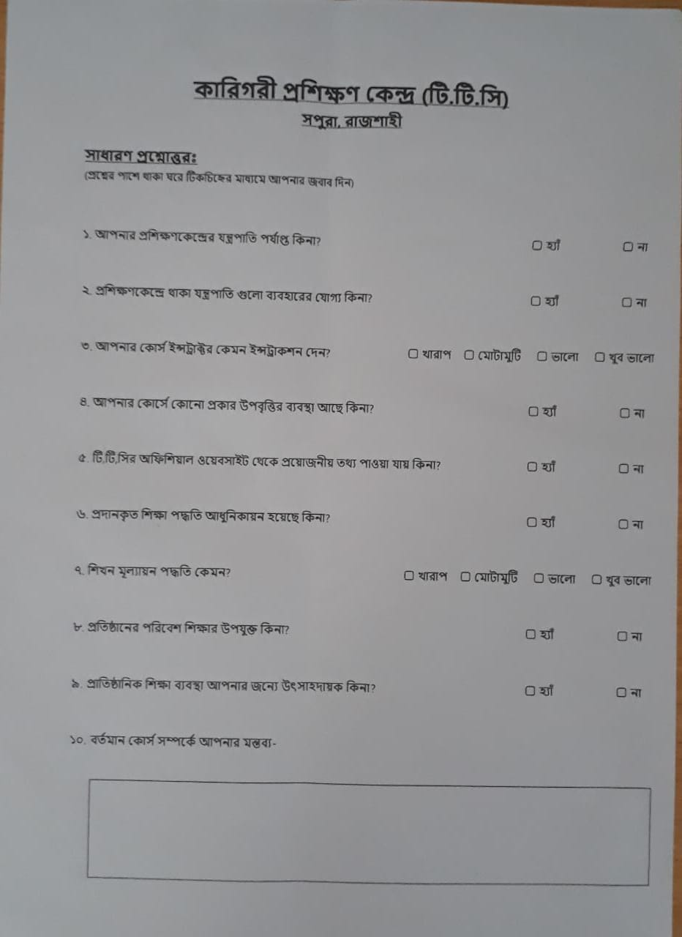

|  |  |  |
| --- | --- | --- |
| Question no | Yes | No |
| 1 | 8 | 2 |
| 2 | 6 | 4 |
| 4 | 7 | 3 |
| 5 | 9 | 1 |
| 6 | 4 | 6 |
| 8 | 9 | 1 |
| 9 | 9 | 1 |

Question no 3: Worst(5%),average(5%),good(25%),best(65%)

Question no 7:Worst(5%),average(10%),good(70%),best(15%)

Question no 10:Instructors are good enough,All the things teached practically.One of the problem is load-shedding happens sometimes.

**3.3 Overview of the candidate examination control system.** The Data flow diagram (DFD) was first developed by Larry Constantine as a way of expressing system requirements in a graphical form; this led to a modular design. A DFD, also known as a “bubble chart”, has the purpose of clarifying system requirements and identifying major transformations that will become programs in system design. So it is the starting point of the design phase that functionally decomposes the requirements specifications down to lowest level of detail. A DFD consists of a series of bubbles joined by lines. The bubble represent data transformations and the line represents data flows in the system. **The DFD of proposed exam system of technical training center,rajshahi**

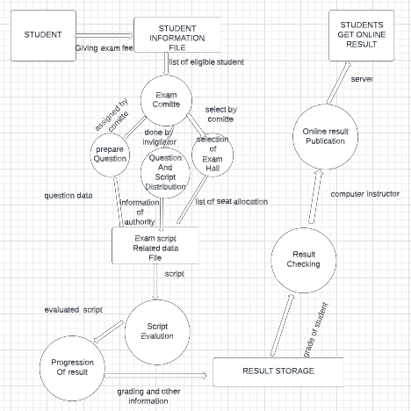

**3.3.1 A brief description of examination control system**

We have shown the examination control system of the technical training center. The process starts with the students. Students are the source of the system. They complete the registration process by giving course fee. The office send the list of eligible students to the exam committee. Exam committee stores these information in their database with care. Then the first process of examination starts through the transmission of the student data. Then this process of exam completes through three sub processes which are prepare question, question and exam script distribution and selection of exam hall. The first sub process is preparing exam question.Committee assigned respected instructor to set question. This selection process is done based upon experience and special training.Then the next sub process is question and exam script distribution. The available teacher is assigned to guard the hall and play the role of invigilator.They distribute the exam script and question on time. Finally the arranging examination process completes with the selection of exam hall . The institutions selected as exam centers selects invigilators and prepare seat plan.The documents of examination hall selection and arranging examination process are stored in data file. The next process is to evaluate the answer scripts. The theory scripts are distributed to the selected examiners. The examiners are given deadline within that deadline they have to complete their evaluation. After evaluation of the exam scripts they submit the mark sheet and the exam scripts to the head examiner and then the head examiner submit the final mark sheet to the office. The OMR sheet checking process is done by the third party organization. Board selects these third party organization. After getting the evaluated theory script marks marks the third process of creating final result starts. This process ends with storing the result and grade the result. Next process is to check the stored result. The result is stored in data file after getting the marks from the examiners . Then corresponding graded result is checked in this process that whether there is any mistake or not. Then the processed and checked result is given to computer operator who handle the website, to publish it online. Through the publication of result overall examination control process ends. Lastly the students get their result through the online server of the institution.

**3.3.2 Conclusion:** Information gathering is an art and a science. A key point of feasibility study is gathering information about the present system. That’s why to gather information we have used four tools. That means we collected the required information using four different criteria. These tools are very useful because the information can be collected by using these tools very effectively. System can be observed closely and at the same time this is an opportunity to build up an amicable relationship with the staffs of the respective organization. By gathering information using the four tools we have mentioned we came to know the actual need of the organization. It will help us in our analysis about the present system. Lastly we sketched a data flow diagram which is a graphical representation of the proposed system of technical training center.Their is not any existing exam system.Only a final exam is taken under board.Their is not any internal examination wich is not good for the students.Without the exam students can not know their lackings and will not be attentive in their study. By data flow diagram one can easily understand and can get a idea of the exam system. So there is important of information gathering to get a idea about existing system and to get a idea about the requirement of candidate system.

**Chapter – 4**

**Feasibility Study**

**4.1 Introduction**

Feasibility study is an exercise which involves documentation of each potential solutions to a particular system. By initial feasibility investigation an analyst determines whether the alternative is feasible or not. The analyst evaluates the candidate system and provides the selection of best system which meets the performance and cost requirement. For feasibility study, we have to consider the three factors of economical, technical and behavioral factors to meet the efficient system. Feasibility study is used for ensuring the system is feasible. An analyst finds the alternatives of problems and gets the selection by which it prevents the more cost and finds if the alternatives make any profit for an organization.

In our analysis on Technical Training Center (TTC) Rajshahi, previously we have identified some problems and we’ve also done our initial feasibility study on those problems. Now we are going to analyze that whether those problems are really feasible to solve or not.

**4.2 Feasibility analysis**

In this section the solutions which are feasible to solve are identified. We have considered some criteria based on the problem and given them weighting factor from 1 to 5. Then we have given rating from 1 to 5 on different criteria of the existing system and proposed system. 5, 4, 3, 2, 1 are for excellent, very good, fair, poor and very poor respectively.

**4.2.1 No online admission system**

We’ve found that, there is no online admission system in TTC website. Students cannot enroll or admit themselves through website. Manual admission system quite complex and time consuming for a training center with 16 trades. So, huge amount of man power is needed to maintain the system.

In initial feasibility study, we’ve seen, though the running system is presumed less effective, but it is quite efficient. Because, TTC Rajshahi doesn’t have their own database server. Even their website runs on others server. On the other hand, payment method for the enrollment need to add some paid APIs of other company like, Bkash, Visa, MasterCard etc. So, it is quite costly to store a database of more than 1500 student’s admission information on any third-party web server & applying those paid APIs.

Again, there are 64 TTC in Bangladesh. Which mean, almost every district has one of it. So, it won’t be a problem for the student from distant areas. Measuring all of those points, online admission system is not needed to add in the system.

**4.2.2 Absence of student’s** **profile**

We’ve found that, there is no featured of student profile in online system. For this reason, students are not able to check their individual progress.

In feasibility study, we’ve it is worthy to resolve the problem. By which, both students & teachers are able to monitor their progress. Again, this process doesn’t require a huge database continuous man power and technical specialist. So, they can store these data in their existing database.

We have made a weighted candidate evaluation matrix to show the effect of adding online student profile.

In this matrix we have considered performance efficiency and in cost section we have considered cost for database design and maintenance. We have given the weighting factor for efficiency is 5, for design cost is 3 and for maintenance we have given the weighting factor as 2. We have multiplied ratings and weighting factor to calculate scores.

Table 4.1 shows the weighted candidate evaluation matrix for adding online admission.

|  |  |  |  |
| --- | --- | --- | --- |
| Evaluation Criteria | Weighting Factor | Present admission system    Rating Score | By adding Online Admission System  Rating Score |
| Performance  Efficiency  Cost  Cost for design  Maintenance | 5    3  2 | 3 15  0 0  2 4 | 5 25  1 3  2 4 |
| Total Score |  | 19 | 32 |

**4.2.3 Lack of online resource**

By initial investigation, we’ve found that, there is not any syllabus, details and course curriculum for specific course in the website. If students can see the course curriculum on the website, they will get some advanced idea. And, there is lack of list of necessary books, pdf, article and video tutorial about a particular course. Students will not get proper idea about their courses before admitting themselves.

But, in the initial feasibility study, we’ve got that, giving more resource on the online is not that feasible. Because, TTC teaches field work to their students. So, there is not such book to study in the class. And the syllabus of the course is well written in the notes that are given to the students at the time of course enrollment. Again, the instructors are well aware on their trade. That’s why there is no need of book in case of teaching. Considering all these points, it’s clear that upload the resources over their website is not necessary rather learning them.

**4.2.4 Online/mobile banking**

In the website of TTC, Rajshahi, there is no such option for course for online payment method after course enrollment. But in initial feasibility study we’ve enlighten that creating an online payment on the system is not worth solving. Because the payment method required of various paid APIs like Bkash, Visa, MasterCard etc. And for a handful number of students, the payment methos over online banking won’t be profitable & feasible at any way.

**4.2.5 Shortage of training of trainer’s**

This organization have a critical shortage of training of trainers which can become threatening for the future training program. The trainers of various sectors are well experienced -no doubt but to keep pace with this competitive world by their skills, they should be trained. Without proper training they can’t teach the trainee properly what the trainee actually needs to know to prepare themselves for suitable jobs.

For any extensive course, the instructors have got their training from Dhaka on their own responsibilities. But not every instructor is able to do so. That’s why, an official training program need to be included in the system for their betterment of skills.

We have made a weighted candidate evaluation matrix to show the effect of increased training of the trainers.

In this matrix, we have considered efficiency, alternatives and speed of processing in performance section and in the cost section we have considered salary and training. We have given 5, 4 and 3 to efficiency, speed of processing and training as weighting factor respectively. We also rated the criteria and then we multiplied the rating and weighting factor to give them scores. In total we can see that the score of increased training of trainers is more than training present training of trainers. So, it is better to increase training of trainers at TTC, Rajshahi.

Table 4.2 shows the weighted candidate evaluation matrix of training of trainers.

|  |  |  |  |
| --- | --- | --- | --- |
| Evaluation Criteria | Weighting Factor | Present training of trainers  Rating Score | Increased training of trainers  Rating Score |
| Performance  Efficiency  Speed of processing    Cost  Training | 5  4  3 | 4 20  4 16    0 0 | 5 25  3 12    4 12 |
| Total Score | | 36 | 49 |

**4.2.6 Not having updating curricula**

Technical Training Center (TTC), Rajshahi has 16 different fields of training. All the fields have particular curricula in order to enhance student learning and facilitate instruction. But these curricula are not totally up to date.

By initial feasibility study, we’ve come to know that, they also not need to change their curricula. because the ongoing curricula is good enough to learn and gain knowledge and skill about the individual field of training. Again, they are able to get their job with perfection with the training they’ve given based on curricula on the running system. So, updating curricula is not needed.

**4.2.7 Insufficient performance monitoring and evaluation**

TTC, Rajshahi has various kinds of courses depend upon time duration. Basically, it is of two types. take short term courses which duration can be 6 months or can participate in long term courses which duration is more than 1 years. At the end of the any course, main branch of TTC, Bangladesh evaluates students by oral & written exam. But, TTC, Rajshahi have no such exam or any evaluation process to judge the outcome of the students they’ve teaches the whole course.

An evaluation process will help the instructors to know the situation of every student. Again, it can be the feedback to their own teaching technique & standardized the progress of TTC, Rajshahi.

We have made a weighted candidate evaluation matrix to show the effect of increased internal evaluation process.

In this matrix, we have considered efficiency and speed of processing in performance section and in the cost section we have considered additional salary and training. We have given 5, 4, 4 and 3 to efficiency, speed of processing, salary and training as weighting factor respectively. We also rated the criteria and then we multiplied the rating and weighting factor to give them scores. In total we can see that the score of increased internal evaluation method is more than training present internal evaluation method. So, it is better to increase internal evaluation method at TTC, Rajshahi.

Table 4.3 shows the weighted candidate evaluation matrix of internal evaluation method.

|  |  |  |  |
| --- | --- | --- | --- |
| Evaluation Criteria | Weighting Factor | Present internal evaluation method  Rating Score | Increased internal evaluation method  Rating Score |
| Performance  Efficiency  Speed of processing    Cost  Additional Salary  Training | 5  4  4  3 | 4 20  3 12    0 0  0 0 | 5 25  4 16    4 16  4 12 |
| Total Score | | 36 | 69 |

**4.2.8 Bad condition of training car**

The cars, those have used in driving trade, are have in very bad condition. They are certainly not in shape of driving & it is quite risky to a car in that condition.

In TTC, Rajshahi, they have cars with perfect condition. But they won’t use them. Again, the car driving zone is the inner area of the TTC. So, there is no risk of accident. Even by a new car driver. And it is just a matter of order from a higher authority to replace the old cars by the newer one.

**4.2.9 Shortage of recreation**

In the TTC there have no event or any program for recreation of the students. Again, the annual program is only for those students those are enrolled in the long-term courses. But there are no such things for the students on short-term courses. Further, they don’t have any scope of sightseeing tour.

In feasibility study, we’ve known that, there are course of various trade of various duration. So, it’s not for every student to take part in an annual program. The students who enrolled in short-term courses have not enough time for recreation. Because, the time duration is only 6 months. In this short period of time there have not much impact of recreation in training process rather than it can be a west of time

**4.2.10 Shortage of security guard**

The TTC area is quite big with 16 trade & intermediate level college education system. Again, they have a separate area for women training purpose. But, in this whole area, there is not a single guard checkpoint. Even in the main gate of TTC there is a guard. But he also not concerns about the outsider who came into this area. By increasing security guards, any unusual phenomenon can be reduced. Outsider intervein in the TTC area can be controlled & Privacy of woman can be preserved.

We have made a weighted candidate evaluation matrix to show the effect of increased security guard.

In this matrix, we have considered efficiency in performance section and in the cost section we have considered salary. We have given 5 and 4 to efficiency and salary as weighting factor respectively. We also rated the criteria and then we multiplied the rating and weighting factor to give them scores. In total we can see that the score of increased security guard is more than training present security guard. So, it is better to increase security guard at TTC, Rajshahi.

Table 4.4 shows the weighted candidate evaluation matrix of increased security guard.

|  |  |  |  |
| --- | --- | --- | --- |
| Evaluation Criteria | Weighting Factor | Present security guard  Rating Score | Increased security guard  Rating Score |
| Performance  Efficiency    Cost  Salary | 5  4 | 4 20    0 0 | 5 25    4 16 |
| Total Score | | 20 | 41 |

**4.2.11 Insufficient advertisement**

This organization manages student/trainee by submitting leaflet, giving post on various social media and through the newspaper. Thus a few people can know about the importance of technical knowledge and skills. For this lack of organizational advertisement, it creates the shortage of the number of the trainee. Almost every class not even have half the students than their capacity.

In feasibility study, we’ve seen that the proper advertisement the organization will spread their facility, there vision and mission. Even the people who want to be technically updated will get information about their service and can enrolled themselves in the organization. Even if, it helps the students to attracts come & join the classes.

We have made a weighted candidate evaluation matrix to show the effect of increasing advertisement.

In this matrix we have considered performance efficiency and in cost section we have considered cost for advertisement and maintenance. We have given the weighting factor for efficiency is 5, for design cost is 4 and for maintenance we have given the weighting factor as 2. We have multiplied ratings and weighting factor to calculate scores.

Table 4.5 shows the weighted candidate evaluation matrix for increasing advertisement.

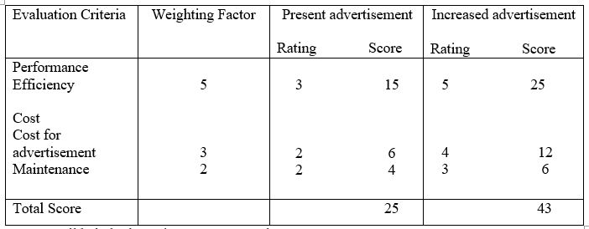

**4.2.12 Not having cafeteria**

In this organization, there is no canteen or cafeteria. During the break time of the courses, there is no chance of the trainee to get foods inside the campus. Even there is no tea stalls or hotel nearby the organization. So, the trainees have to go a long distance when they need to take any food. It is not good to stay a long time in the class without having food. Even if, it distracts our concentration from the class. So, having a cafeteria or canteen is must in the system. It’ll help both our instructors & students.

We have made a weighted candidate evaluation matrix to show the effect of making a cafeteria.

In this matrix, we have considered efficiency and speed of processing in performance section and in the cost section we have considered infrastructure cost and maintenance. We have given 5, 4, 4 and 3 to efficiency, speed of processing, infrastructure cost and maintenance as weighting factor respectively. We also rated the criteria and then we multiplied the rating and weighting factor to give them scores.

Table 4.6 shows the weighted candidate evaluation matrix of having cafeteria.

|  |  |  |  |
| --- | --- | --- | --- |
| Evaluation Criteria | Weighting Factor | Running system without cafeteria  Rating Score | Proposed system with cafeteria  Rating Score |
| Performance  Efficiency  Speed of processing    Cost  Infrastructure cost  Maintenance | 5  4  4  3 | 0 0  0 0    0 0  0 0 | 5 25  4 16    4 16  2 6 |
| Total Score | | 0 | 63 |

**4.2.13 Lack of Man Power**

TTC Rajshahi have almost of 1500 students at a time with 2 shifts. But they have 55 instructors in the institute. We have also learned that there is only one foreign instructor from Korea who acts as a monitor of the training courses through online. But they still have a shortage of the 31 instructors.

Lack of trainer is a dangerous problem for an educational institute. It will cause insufficient knowledge of the student in their individual training field. The organization need to appoint more instructor in different field so that the learning process become more effective. It will encourage people to enroll themselves in different field of training.

We have made a weighted candidate evaluation matrix to show the effect of increased trainers.

In this matrix, we have considered efficiency, alternatives and speed of processing in performance section and in the cost section we have considered salary and training. We have given 5, 4 and 4 to efficiency, speed of processing and salary as weighting factor respectively. We also rated the criteria and then we multiplied the rating and weighting factor to give them scores. In total we can see that the score of increased trainers is more than training present trainers. So, it is better to increase trainers at TTC, Rajshahi.

Table 4.7 shows the weighted candidate evaluation matrix of increased trainer.

|  |  |  |  |
| --- | --- | --- | --- |
| Evaluation Criteria | Weighting Factor | Present trainers  Rating Score | Increased trainers  Rating Score |
| Performance  Efficiency  Speed of processing    Cost  salary | 5  4  4 | 4 20  3 12    3 12 | 5 25  4 16    4 16 |
| Total Score | | 42 | 57 |

**4.2.14 Inadequate Staff Quarter**

In the Back side of TTC area, there are only 5 two storied building in the compound for the instructors. And we know, there are 55 instructors in the institution. Certainly, those buildings are for at max 10 families. So, most of the instructors have to stay outside the area. Again, they don’t have any stuff quarter.

More staff quarter will encourage the people to appoint themselves as an instructor. It’s safe and convenient for instructor to do their job effectively. It will reduce instructor economical losses. In future when the organization turn on more training field, more staff will be needed. That’s why sufficient staff quarter is much needed.

We have made a weighted candidate evaluation matrix to show the effect of making a cafeteria.

In this matrix, we have considered efficiency in performance section and in the cost section we have considered infrastructure cost and maintenance. We have given 5, 4 and 3 to efficiency, speed of processing, infrastructure cost and maintenance as weighting factor respectively. We also rated the criteria and then we multiplied the rating and weighting factor to give them scores.

Table 4.8 shows the weighted candidate evaluation matrix of increased quarter.

|  |  |  |  |
| --- | --- | --- | --- |
| Evaluation Criteria | Weighting Factor | Present teacher’s quarter  Rating Score | Increased teacher’s quarter  Rating Score |
| Performance  Efficiency    Cost  Infrastructure cost  Maintenance | 5  4  3 | 3 15    2 8  1 3 | 5 25    4 16  3 9 |
| Total Score | | 26 | 50 |

**4.3 Conclusion**

In this chapter, we’ve done feasibility study. By, which, we can now able to sort out the problems that are worth solving. It is one of the most important stages in system development life cycle. We’ve done our analysis with considering both performance & cost. The scored value of each worth solving problem give us the intuition that, what is best to done with the system. The deep analyzation of each field shows the best outcome of possible solution.

**Input/Output Form Design**

**Chapter - 5**

**5.1 Introduction**

A form is a paper with questions on it and spaces marked where we should write the answers. Forms usually ask us to give details about ourselves. Forms are the product of input and output design. It provides fields for data input. During form design we have to know-

* Who will use them
* Where would they be delivered
* The purpose of the form

Types of forms-

* Main forms or Regular forms- To create a regular form, we will see the eight core fields.
* Composite forms or Join forms- When data is stored in multiple forms and we want to display the data in a single form.
* Inline forms- It is automatically load embedded forms on a view fields based on user action.

**5.2 Form Design for Technical Training Center (TTC)**

In the process of system analysis in Technical Training Center (TTC), Rajshahi, several types of forms were required. Here the main focus of the analysis was to work on the forms relating the student information and instructor information. So to gather information about both student and instructor is a quite complex and lengthy process. So there are a lot of processes need to be performed. That’s why we need a well and effective data management system must be established. So for gather information we need two forms for the purpose. The first one is for student information related form and the second one is instructor information related form. These forms were designed keeping in mind about how the forms would interact with the central database. The forms contain one or more information with details like for student his or her id, name, father’s name, mother’s name, gender, grade etc. and for instructor his or her id, department name, email, gender, salary etc. from the database. The details here means information about students and instructor related. The forms can be filled up online or any software can be introduced which will reduce the time.

**5.2.1 Student Information related form**

This form is designed for students. The form contains information about students. The fields of the forms are described below:

1. **Student Id:** Id is a unique identification code. Every student has a unique id. This id is stored in the main database form where the identity of the student can be easily found. And the database starts with the id of a student.
2. **Student Name:** Student name is also stored in the database form .After the unique identity code student name is also important to know about the student details.
3. **Father’s Name:** To know more about a student his or her father’s name is important. That’s why father’s name is also stored in the database form.
4. **Mother’s Name:** To know more about a student his or her mother’s name is important. That’s why mother’s name is also stored in the database form.
5. **Email:** A student have a unique email to identify his or her properly. This email is stored in the database form.
6. **Student Phone Number:** A student have a unique phone number to identify his or her individually. And this phone number is stored in the database form.
7. **Birth Date:** This is a very important tool for a student. In the database form it will stored by her or his birth details like his or her birth month, day, year.
8. **Gender:** It will be specifying that the student is male or female. And it is stored in the database form.
9. **Entry Year:** The year is indicated that the student is from which batches. That’s why it is stored in the database.
10. **Grade:** Grade is a most important tool for a student to identify what result he or she done in the examination. So it is stored in the database form.
11. **Current Address:** The current address of a student means where he or she lives at present. That means the present address. It is stored in the database form.
12. **Primary Address:** The primary address of a student means the specific information like building number and street number in an address. It is also stored in the database form.
13. **Edit:** When a student fill up this form and if any data is incorrect then the student can use this option to correct the information.
14. **Submit:** After all the data entry is finished this button will be used. Once this button is used all the information of the students will be stored in the database.

**Student Information related form**

**Technical Training Center (TTC), Rajshahi**

**Student Id**

Ex: 234567

**Student Name**

Ex: Zareen

Pear

Tasnim

First Name Middle Name last Name

**Father’s Name Mother’s Name**

Ex: Rehena Parvin

Ex: Hasan Mamun

**Email Phone Number**

Ex: 01771232955

Ex: mim12@gmail.com

example@example.com Enter Number

**Birth Date Gender**

Please select

Month Day Year

**Entry Year Grade**

Please select

**Current Address Primary Address**

Ex: Shapahar, Naogaon

Ex: Vodra, road no-15/5, Rajshahi

**SUBMIT**

**EDIT**

**5.2.2 Instructor Information related form**

This form is designed for instructors. The form contains information about instructors. The fields of the forms are described below:

1. **Instructor Id:** Id is a unique identification code. Every instructor has a unique id. This id is stored in the main database form where the identity of the instructor can be easily found. And the database starts with the id of an instructor.
2. **Instructor Name:** Instructor name is also stored in the database form .After the unique identity code instructor name is also important to know about the instructor details.
3. **Department Name:** Department name is also a specific identity to identify an instructor belongs to that department.
4. **Email:** An instructor have a unique email to identify his or her properly. This email is stored in the database form.
5. **Instructor Phone Number:** An instructor have a unique phone number to identify his or her individually. And this phone number is stored in the database form.
6. **Gender:** It will be specifying that the instructor is male or female. And it is stored in the database form
7. **Instructor Salary:** Instructor salary is also stored in the database form. It’s also an important tool.
8. **Current Address:** The current address of an instructor means where he or she lives at present. That means the present address. It is stored in the database form.
9. **Primary Address:** The primary address of an instructor means the specific information like building number and street number in an address. It is also stored in the database form.
10. **Edit:** When a instructor fill up this form and if any data is incorrect then the instructor can use this option to correct the information.
11. **Submit:** After all the data entry is finished this button will be used. Once this button is used all the information of the students will be stored in the database.

**Instructor Information related form**

**Technical Training Center (TTC), Rajshahi**

**Instructor Id**

**Ex: 1234**

**Instructor Name**

Ex: Golam

Sarkar

Mostafa

**First Name Middle Name last Name**

**Department Name**

**Ex: Computer**

**Email**  **Instructor Phone Number**

Ex: 01771232955

Ex: mos12@gmail.com

example@example.com Enter Number

**Gender Instructor Salary**

Please select

Enter Salary

**Current Address Primary Address**

Ex: Mahedepur, 54/2, Naogaon

Ex: New market road, 513/2, Rajshahi

**SUBMIT**

**EDIT**

**5.3 Conclusion**

To build a proper database system the input output and forms are necessary medium. In this digital world, database system is paly a very important role. Any people can find anything about the instructor and students details very quickly. So, it really ensure better performance for a system. The technical training center has to maintain a huge amount of data, the forms and database system which must be helpful. Day by day the number of students and instructors are increasing and handling those amount of data is becoming quite complex process. That’s why proposed forms were designed. But after some years they need to change the forms. But as the forms are interacting with the central database, the modification needs to be handles properly. Here the forms are designed very effectively to process digitally. So, a digital system must be designed to implement those forms in use. The implementation can be done using a website or a software. Since the form will be interacting with the central database and the result system is a very confidential process, a separate software with the ability to interact with the database is recommended. But this process needs a qualified expert team and regular maintenance. A technical support team can be appointed for this purpose.

**Chapter 6**

**Database Design**

**6.1 Introduction**

Database is a collection of interrelated data stored with minimum redundancy to serve many users quickly and efficiently. Mainly database is used to maintain information as an integrated whole and make information access easy for the user. Similarly Technical Training Center (TTC) needs various database with so many tables for processing student profile, evaluating their result, Online payment system etc. that will help the corresponding user to receive their required data in a very efficient way.

**6.2 Database for Organization management system**

Organizational management system includes student/trainee profile, Courses, instructor profile, Online payment system. For generating student management system, we have to collect student’s/ trainee’s personal information such as ID, name, father’s name, age, address, course id, phone number. Another table is required to show the course which consists of course id, course name, course instructor name. The information of the instructors of various courses will be contained in instructor table. In instructor table, there will be instructor ID, instructor name, Designation, Salary, Phone Number. For ensuring payment status, payment table will help which includes student ID, Course ID and payment status.

Hence, database contains four tables for processing the data of student, instructors and courses.

They are-

1.TRAINEE PROFILE

2.INSTRUCTOR PROFILE

3.COURSES

4.PAYMENT

The TRAINEE PROFILE gives the very basic information of the trainee such as his/her ID, name, father’s name, age, address, phone number, Course ID. When such kind of information will be required then this table will be helpful.

The INSTRUCTOR PROFILE contains the detail information about instructor of this organization. From this table, the name of the instructors, their designation, the courses they conduct, phone number and their salary status can be obtained.

The COURSE table contains the information of course ID, the name of the corresponding courses and the instructor’s ID who takes the course.

The Payment table verifies whether the payment status of the trainee is clear or not. For this purpose, this table includes the ID of the trainee, course ID, payment status.

**6.2.1 Entity Relationship Diagram:** Entity relationship (ER) diagram of a database, shows how tables are related to each other. ER diagram gives the brief idea of the database.

Figure 6.1: Entity Relationship diagram of entire organization management system

PAYMENT

TRAINEE PROFILE

INSTRUCTOR PROFILE

ORGANIZATION MANAGEMENT SYSTEM

COURSE

**6.2.2 Structure of tables**

**The structure of each table are shown in 6.2,6.3,6.4 and 6.5**

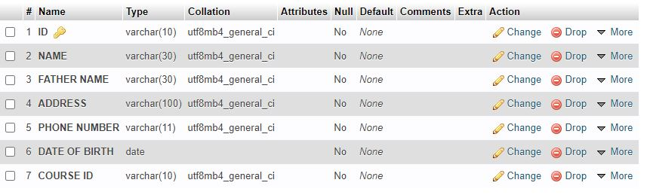

Figure 6.2: Structure of TRAINEE PROFILE table

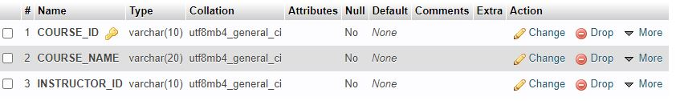

Figure 6.3: Structure of COURSE table

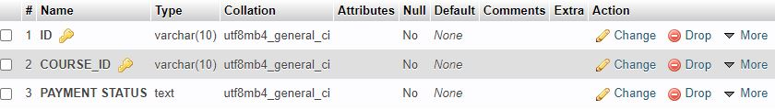

Figure 6.4: Structure of PAYMENT table

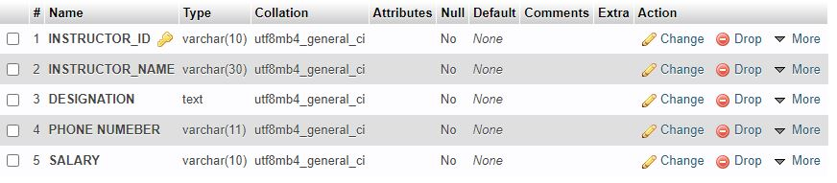

Figure 6.5: Structure of PAYMENT table

**6.3 Conclusion:** Usage of these tables help to obtain redundant free data. In all the tables all the attributes has used effectively. For example, in payment table the name of the trainee is not necessary to get the data. In this case, only trainee ID can uniquely identify the data. So all the attributes are used according to the user demand. By proper using of attributes help the user to reduce query time and get proper information from specific data table. This type of database design makes the best use of space as well.

**Chapter 7**

**Summary of System Analysis and Design on Technical**

**Training Center, Rajshahi**

In this report, we have analyzed the existing system of the Technical Training Center (TTC), Rajshahi.

Rajshahi Technical Training Center is one of the old and large technical training centers in the history of skills development in Bangladesh. This technical training center is established to train the manpower for local and global market. This institution has widely spread mission and vision to provide opportunity of skill development and technical education to all sections of the society without any gender bias. This institution is working to transfer technical knowledge to the grass root level.

This institution tries its best to achieve its organizational goal. To increase the facilities, it has started to work with Korean organization cooperatively. Bangladesh Government has financed in almost all the trades to build up well decorated environment for training purpose as well. Already they have started to build up several buildings including the administration building under the KOICA project. All the steps have taken to enhance the facilities of the training.

This institute has particular mission and vision. To fulfill its mission and vision, it has already taken certain steps such as they have arranged so many workshop and seminar to understand the market demand of various trade. They invite many well reputed businessmen to their organization to motivate the trainee and to supply proper guideline how they should be trained. This organization’s mission can’t be fulfilled overnight. It is a very slow process. But it helps to achieve organizational goal. By analyzing 10 ten years statistics, we can observe that this organization is improving day by day.

In our analysis on existing system of this organization, we have found 14 problems. The main problems are proper orientation of database and shortage of technical people. The number of instructor is very less compare to the number of the trainee. Moreover, there is also lacking of staffs. Here only 86 staffs work as an attendant, office staff or clerk. So it becomes very difficult for them to manage all the things with this limited number of staffs. In initial feasibility study, we suggest to increase the man power and in feasibility study we have shown how increasing the man power is more beneficial.

While we were browsing their website, we found that there is no option for student profile. The institution has no online documentation of the student/trainee. So we recommended to have student profile from which the necessary data of the trainee of various trades can be accessed. In initial feasibility study, it was shown that this process doesn’t cost so much. In feasibility study we have shown the details why it is a cost effective process.

We have identified that there is lack of online resources or course materials which can be better for the trainee to understand the course fruitfully. The instructors deliver typical lecture during the courses. Any changes in this system, requires so many people with technical knowledge. Besides, to access those materials, the trainee should have basic knowledge of using online materials. But when we went to on-site visit, we realized that most of them are not used to use internet. So the trainee will prefer the traditional system. So, in initial feasibility we have mentioned this problem as a worthless. Moreover their curriculum is not so much up to date. This problem also can’t be solved. With the updated curricula, the trainers have to be trained in a new manner and that will cost a lot.

We have also found so many problems like not having online payment system. This problem can’t be solved as in this case the institute requires own server. To set up a server may not be beneficial for the organization because they will definitely need of server managing committee to operate the server. Thus the personnel cost will increase and the output will be very less. Considering these issues, we have decided not to change the system of offline payment.

We have collected information about the training of trainers of this organization and could know there is no opportunities of their training. In initial feasibility study we recommended that this problem can be solved if the trainers willingly involved themselves to learn the skills, knowledge from various resources from online. We have upheld how this steps will be helpful for the instructors, trainee and overall the organization.

We have noticed that this organization has limited performance monitoring and evaluation method. In initial feasibility study we have selected class test type exam to monitor the performance of the trainee. This will help the instructor to understand the learning stage of the trainee. In feasibility study we have decided how this problem can be actually solved by implementing class test type exam. We have sketched a data flow diagram (DFD) how the internal examination can be implemented fruitfully in this organization.

While entering the institute we observed that there were no security guard in the main gate. So unauthorized people often can enter the campus. There are a lot of women who have enrolled in various courses. Their security becomes major issue in this case. So we have considered this as a problem and in initial feasibility we have decided that this problem can be solved by establishing guard protection and using CCTV camera in various spot of the campus. After gathering information, in feasibility study we have analyzed the cost of solving this problem.

Taking interview of the respected Principal, we came to know that there is shortage of advertisement of various trades of this organization. So most of the time they fail to attract the common people to be trained. There are lots of machineries which are being unused year after year for the small number of trainee. If they can take necessary steps, the situation will be changes. So we proposed a system to increase the advertisement system. Micing in various places of the town, workshop, seminar should be arranged which we have shown in initial feasibility study. The required cost of solving this problem has considered in feasibility study.

We observed that there was no cafeteria in the campus. In initial feasibility study we considered it as worth solving by setting up a cafeteria in the campus for the betterment of the trainee. The more concerning problem of this organization is not having sufficient staff quarter. With only two buildings of the quarter can’t satisfy the need of staffs. So it will be very beneficial to arrange fund for sufficient amount of buildings. In feasibility study we analyzed that this problem can be easily solved by using government fund and with the help of Korea project.

We have managed different kind of sources to get information about TTC such as their website, statistics, various official form etc. We have visited their organization to see the working method, interrelationship between the people involved in it. We have also interviewed the respected principal and some of the instructors to collect the information. We have arranged questionnaire so that we can get authentic information from the trainee. Thus using these tools, we came to know the inner details of the organization.

We have designed input/output form to get the information of the trainee, the information of trainer as well. The form is not a paper written form used as offline system but it is a digitalized media. So it should be published on the official website if the organization. From the website, the students can write down the information which are required. Similarly for the trainer, another form has designed. The trainer also can submit their information through the form. To maintain all of these works done, a well trained technical team is required for the organization.

To store the information of the student, trainer, courses and payment we have designed four tables. To query any information in a efficient way, the database has designed to avoid redundancy of data. All the attributes for the four tables have chosen according to the needs. Further, it was kept in mind while designing the database that every attribute is not necessary for finding a specific information. Thus the proper design of the database will help the organization to query any information in very short time from the specific data table.

In the whole procedure of system analysis, we have experienced that all the people involving this organization are very cooperative. They helped us by giving the required information for analyzing their system. By this system analysis we have tried to understand the existing system of this organization and changed the system where it is necessary. We have suggested seven problems to be solved and the rest are not economically feasible. We hope that TTC will change their existing system according to this system analysis to impart Technical Education & Training and to provide substantial number of technicians in different disciplines for the emerging industrial fields of the country.